BOAT TRIP INVITATION

We would like to invite you to a sightseeing boat trip on the River Danube on the occasion of starting your student life in Budapest.

Meeting on Thursday, 5th September, 2019
Boarding: 5.30 p.m.
at the lower Danube embankment on the Pest side at Vigadó
(Half way between Elizabeth & Chain Bridge,
Vigadó tér /square/ Ship station nr. 5)
The name of the boat is Táncsics.
Departure: 6 p.m.
Arrival: 8 p.m.

FREE OF CHARGE
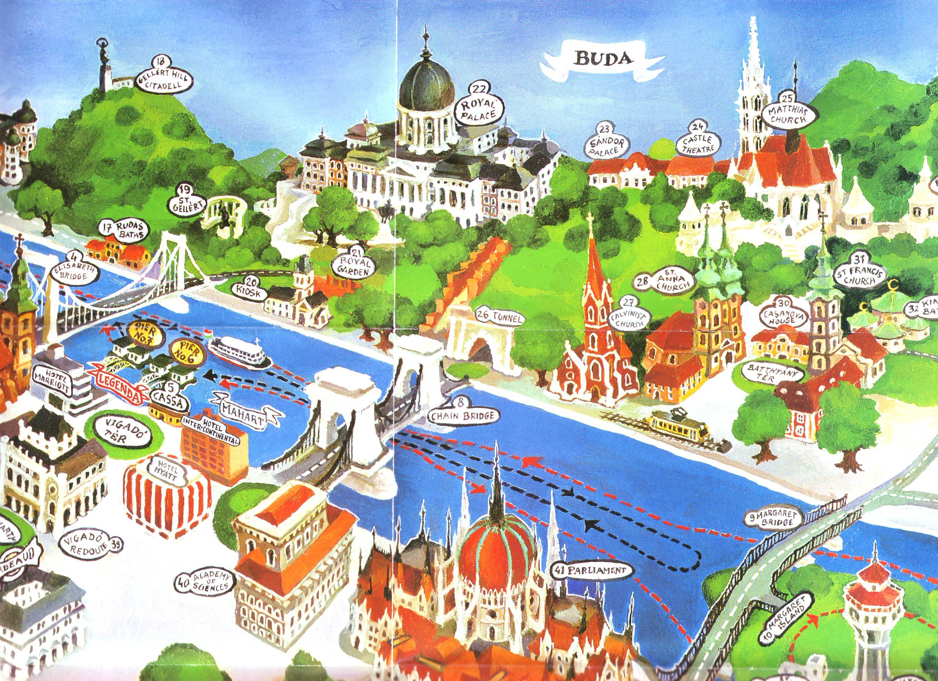

HERE

College International – McDaniel College
University of Veterinary Medicine, Budapest (UVMB)

