**Student programmes for the spring-term**

**organized by the Students’ Secretariat**

1. **Diósgyőr castle – Demjén thermal cave spa 7th March, Saturday 7.00 – 21.00**

for 60 students

start: 7.00 bus stop at István utca

arrival at Diósgyőr castle by 10, guided tour int he castle

arrival at the Cave bath in Demjén

**Participation is free!** The program includes the castle entrance fee, guided tour, spa entrance ticket.

Please prepare your own sandwiches and drink for the daytrip, you can buy your own lunch at the spa self-service restaurant.

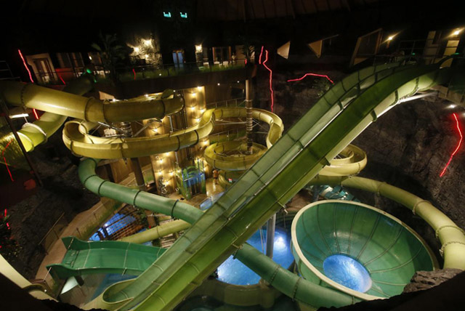Arrival at István utca around 9.00 PM.

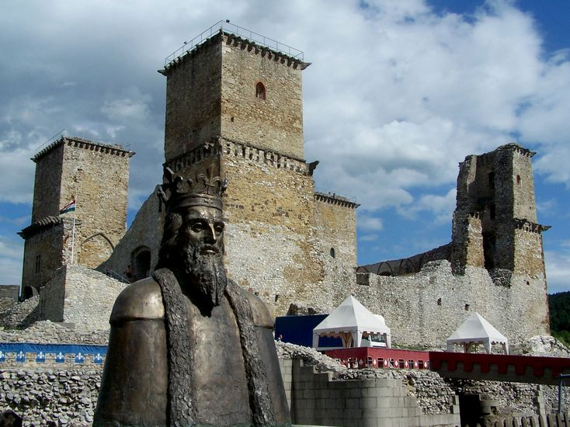

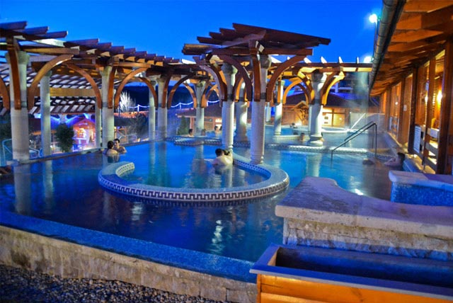

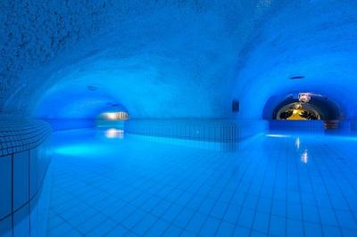

1. Equus Palinka quiz
2. **Székesfehérvár, Bory-castle + wine tasting 18th April, Saturday 8.30 – 19.00**

For 50 students

Start: 8.30 trolley bus stop at István utca

Arrival at Székesfehérvár, Bory-castle by 10.00. There will not be a guided tour, you can explore it on your own. Please prepare your own sandwiches for lunch. If the weather is nice, we may have a small picnic in the garden of the castle.

After the castle visit, we will take part in a 2 hour wine tasting (some fingerfood will be offered too)

After the wine tasting, for about another hour, you will be able to buy yourself drinks, if you are still thirsty :)

Arrival at István utca the latest by 19.00!

Participation is free!

