BOAT TRIP INVITATION

We would like to invite you to a sightseeing boat trip on the River Danube on the occasion of starting your student life in Budapest.
Meeting on Thursday, 8th September, 2022
Boarding: 5.30 p.m.
at the lower Danube embankment on the Pest side at Vigadó
(Half way between Elizabeth & Chain Bridge,
Vigadó tér /square/, ship station nr. 6)
The name of the boat is Rákóczi.
Departure: 6 p.m.
Arrival: 8 p.m.

FREE OF CHARGE

but registration is required, under the following link:

https://docs.google.com/forms/d/16WWdacrMUKgO2Bh-SJIR75AJzdV7UuKfsNrNgD0oMV4/edit

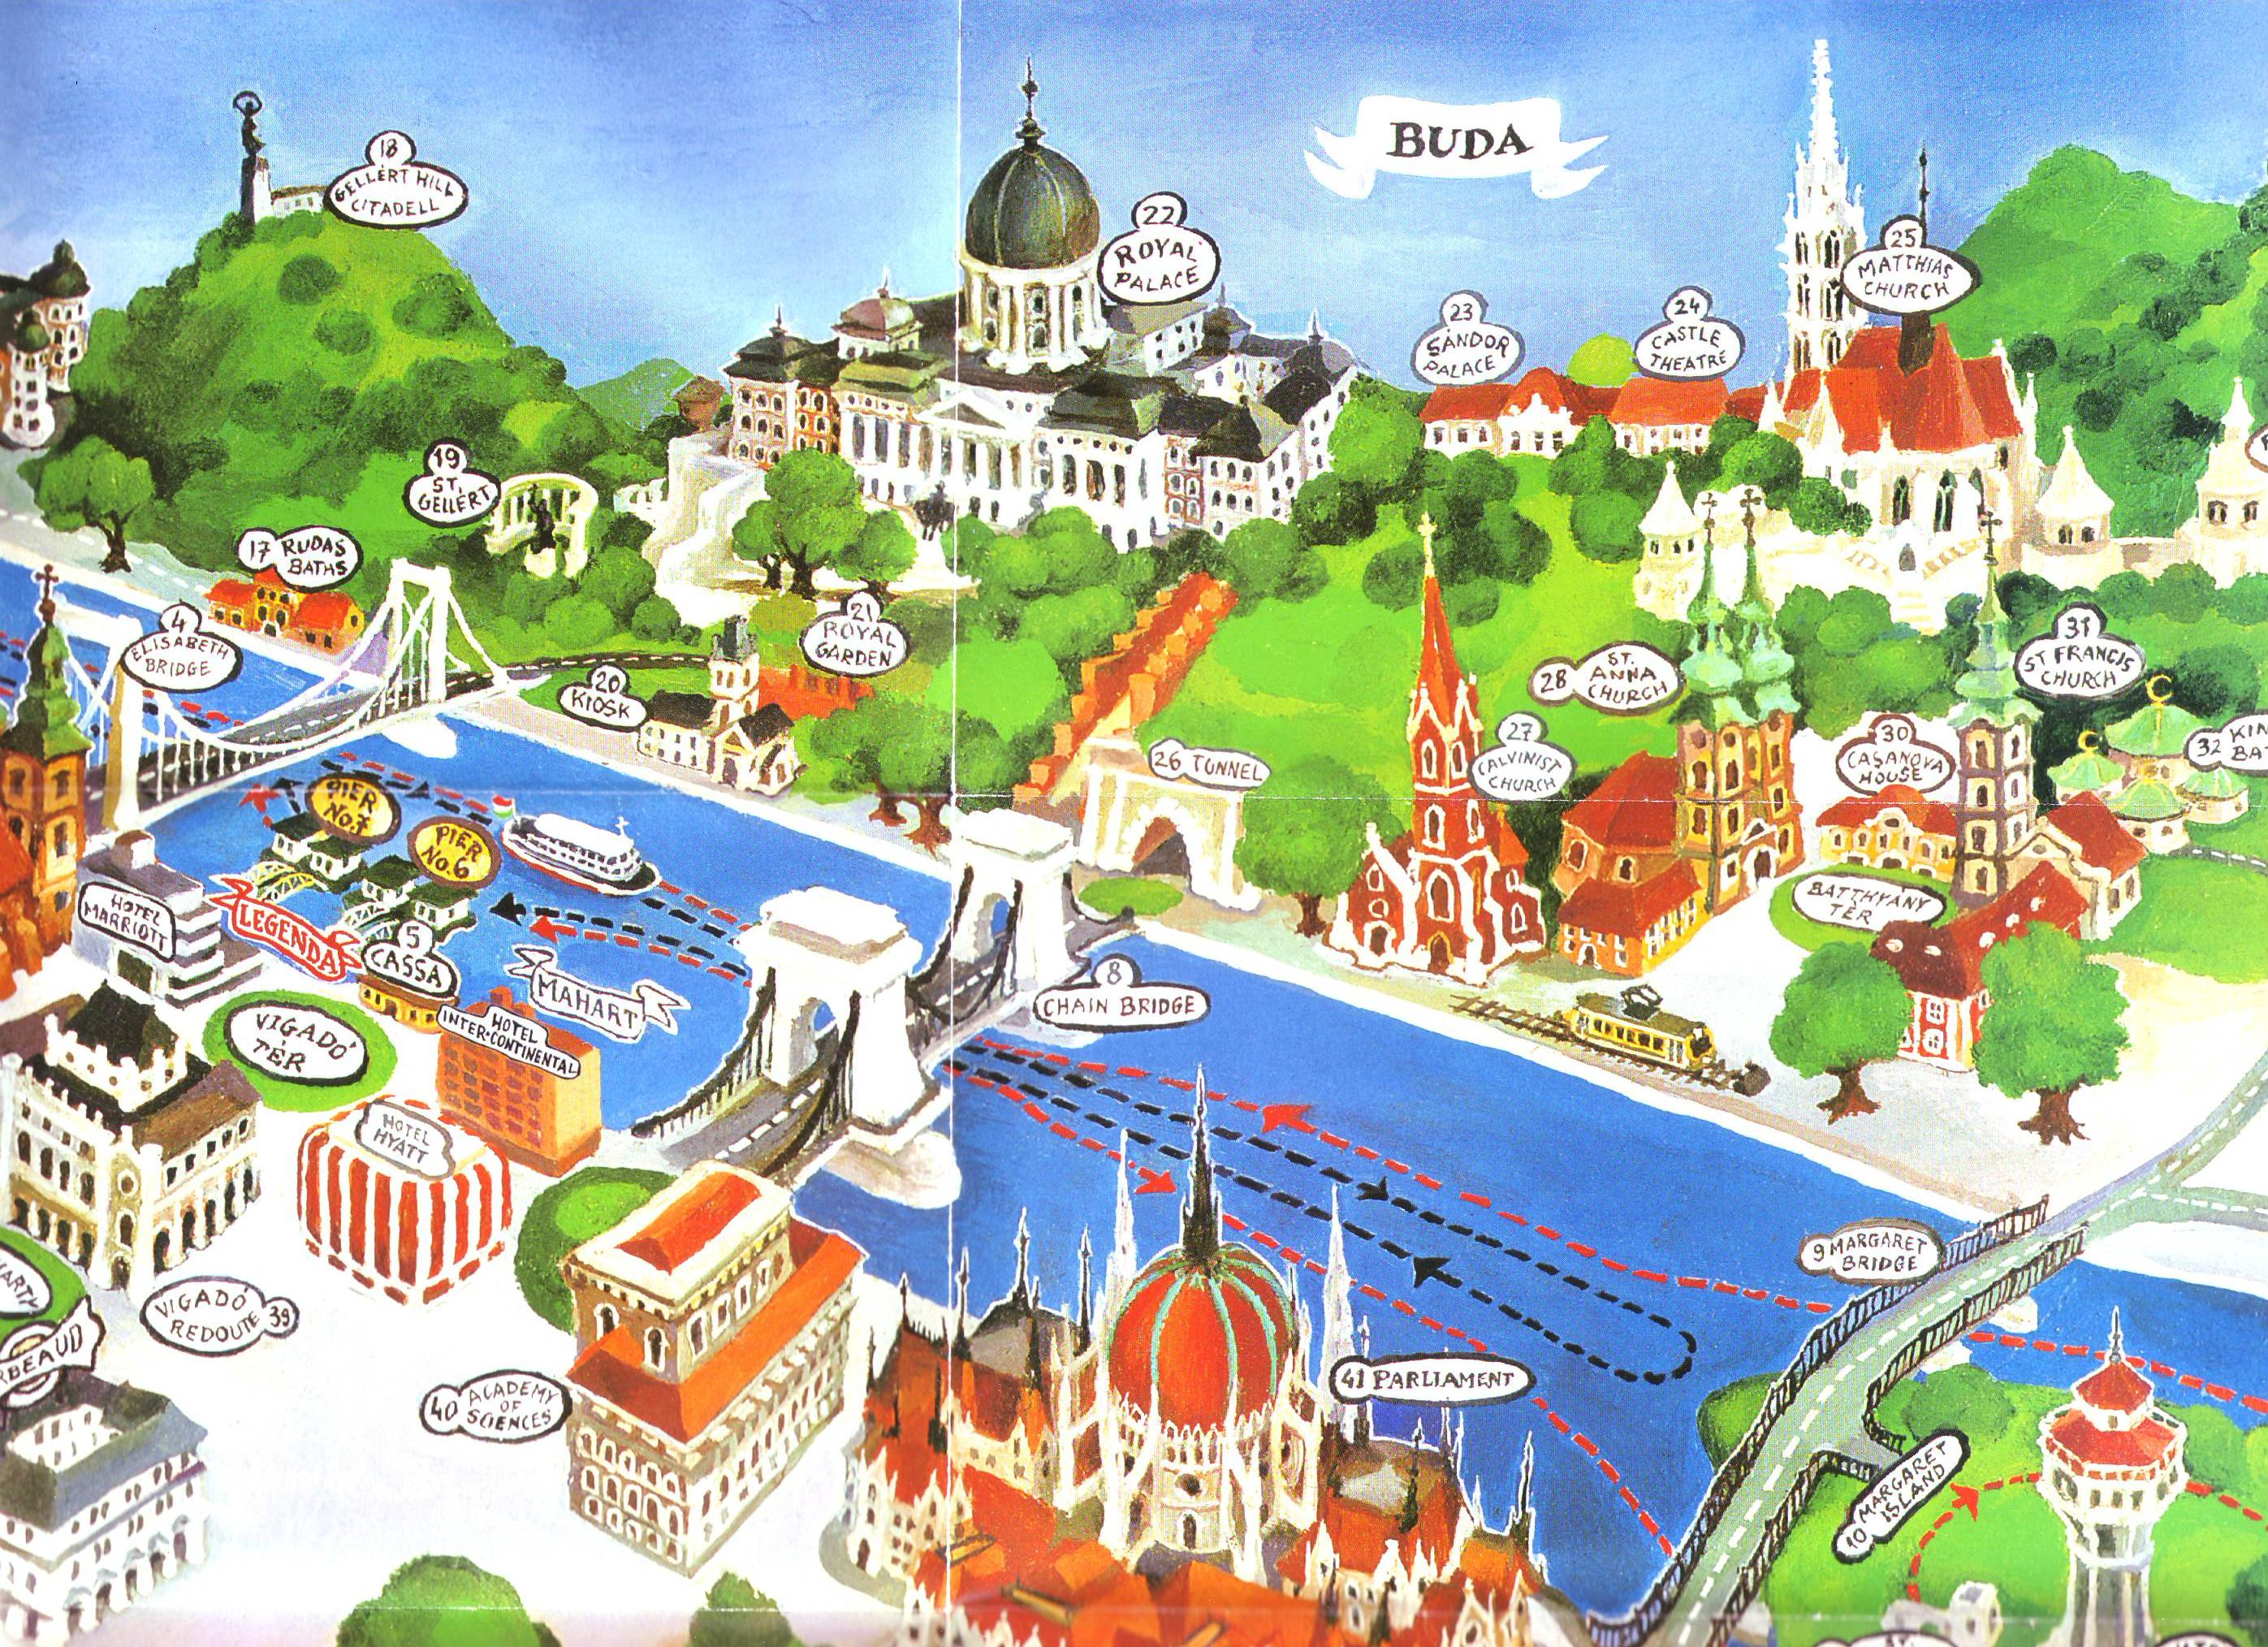

HERE

College International – McDaniel College
University of Veterinary Medicine, Budapest (UVMB)

