BOAT TRIP INVITATION

We would like to invite you to a sightseeing boat trip on the River Danube on the occasion of starting your student life in Budapest.
Meeting on Thursday, 31st August, 2023
Boarding: 5.30 p.m.
at the lower Danube embankment on the Pest side at Vigadó
(Half way between Elizabeth & Chain Bridge,
Vigadó tér /square/, ship station nr. 6)
The name of the boat is Rákóczi.
Departure: 6 p.m.
Arrival: 8 p.m.

The time can still change, it is not 100% sure. We will inform you about the exact time and place of the departure. Thank you for your time.

FREE OF CHARGE

but registration is required, under the following link:

https://docs.google.com/forms/d/1O1-eso8gXH2fqBvrAihUsKSGODF6YHjj3B-x-sdi840/edit

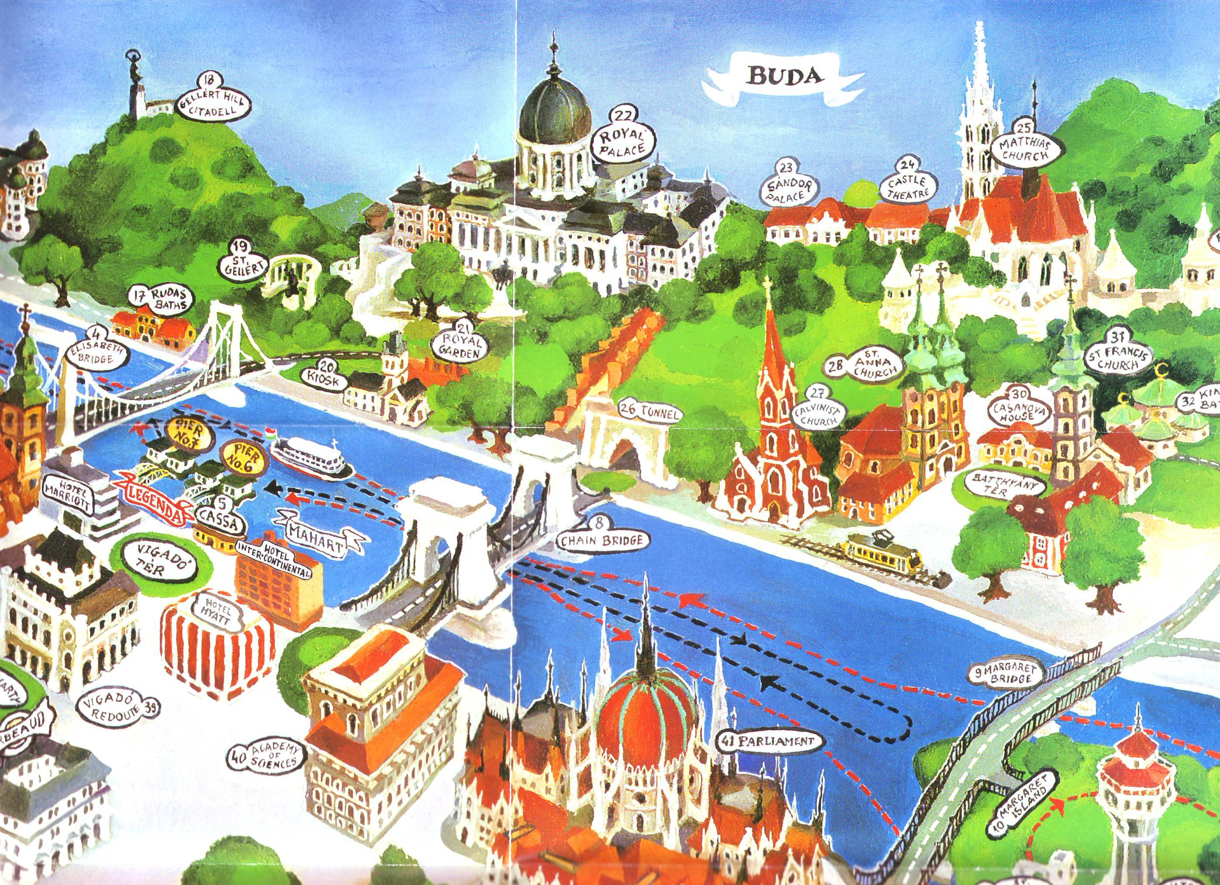

HERE

College International – McDaniel College
University of Veterinary Medicine, Budapest (UVMB)

