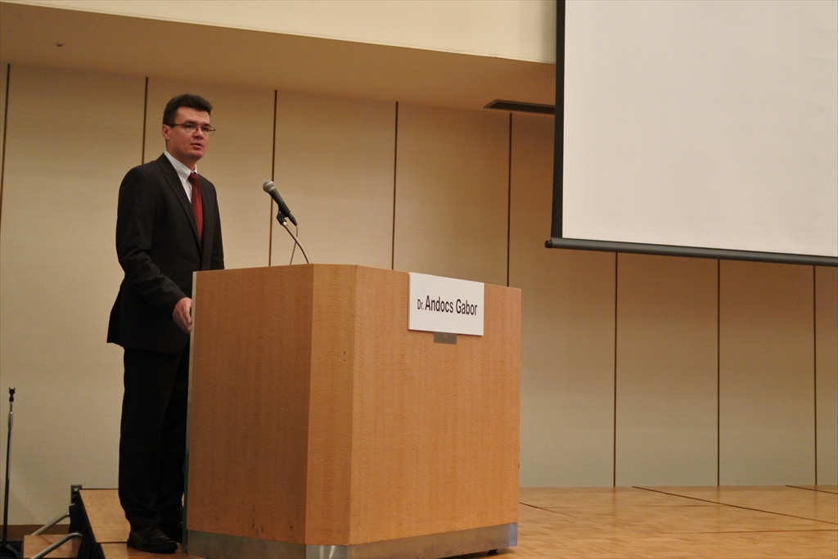
Gabor Andocs, DVM, Ph.D.

Budapest, Hungary

Contact: +36 20 4353635
gandocs@gmail.com
andocs.gabor@univet.hu

https://www.linkedin.com/in/gaborandocs/

Research Scientist

Experienced, innovative, results-driven scientist with over 20+ years of experience within the scientific R&D sector. Possesses a solid foundation in cancer research, in vivo tumor models, in vitro procedures and general isotope and animal experimental work demonstrated through experience as a Research Scientist at Tateyama Kagaku Group. Outstanding researcher able to work alone or with diverse colleagues to produce value and deliver results on time and under budget.

Core Competencies
- Animal Experimental Work | - Cell Culture | - Tumor Immunology
- Molecular Biology | - In Vivo Tumor Models | - Scientific Presentation
- Comparative Oncology | - Biomedical Imaging | - Project Management

Professional Experience

UNIVERSITY OF VETERINARY MEDICINE, BUDAPEST 2021- PRESENT

Research Scientist, Department of Anatomy and Histology, Redox Biology Laboratory
- Investigating different redox biology processes in relation with cancer

TATEYAMA KAGAKU GROUP | TOYAMA, JAPAN | 2012-2021

Research Scientist, Toyama University Graduate School of Medicine and Pharmaceutical Sciences (2014-Present)
Research Scientist, Tottori University Faculty of Veterinary Medicine, Department of Surgery and Oncology (2012-2014)
- Aligned experiments with electro-hyperthermia method (oncothermia). Diligently planned, conducted and evaluated in vitro (cell line models) and in vivo (mouse xenograft and allograft model) experiments with regards to various medical devices.
- Adeptly established the oncothermia tumor treatment method in the veterinary practice (comparative oncology) through rigorous testing, operating and development of the dedicated veterinary oncothermia device whilst collaborating closely with the engineers of Tateyama Machine and Oncotherm Ltd.
- In addition, as a Research Scientist, adroitly developed specialized oncothermia treatment protocols for veterinary clinical oncology practice in 2012-2014.
- Support oncological application efforts within Toyama University Graduate School of Medicine;
- Designed, prototyped, and tested various atmospheric pressure medical plasma systems for oncological application.
- Performed in vitro and in vivo (allograft tumor models) testing of the antitumor effect of the plasma medical devices throughout 2019 to 2021.

OncoTerm Ltd | Budapest | 2006-2012

Freelance Researcher - Veterinarian
- Aligned experiments with electro-hyperthermia method (oncothermia). Diligently planned, conducted and evaluated in vitro (cell line models) and in vivo (mouse xenograft and allograft model) experiments.
- Charged with establishment of the oncothermia tumor treatment method in the veterinary practice.
- Drafted and executed detailed plans and prototyped experimental treating devices for in vitro and in vivo elecro-hyperthermia experiments during 6 years employment span.
- Applied in-depth expertise to conduct rigorous investigations into various different bio-electromagnetic phenomena on tumor models.

CEVA PHYLAXIA, Veterinary Biologicals Co. ltd | Budapest | 2005-2006

Research Associate
- Assumed responsibility as Research Associate and conducted animal test work (virus vaccine test in poultry farm). During testing, expertly isolated chicken anaemia virus (CAV), propagation in bird cell lines, titrate, culminating in successfully developing virus detection immunohistochemical methods.
- Cross-leveraged profound experience with animal experimental work and in vitro work and successfully maintained in vitro cell cultures from human and animal origin.

sanofi-synthelabo, Chinoin | Budapest | 2002-2005

Research Associate
- ADME (Pharmacokinetics and Metabolism) working group
- Planned, conducted and documented in vivo pharmacokinetic studies according to the GLP standards.
  - Handled 14C-radiolabelled drug compounds.
- Expertly conducted large scale animal studies with drug candidates in mice, rats, rabbits, dogs and documented according to GLP standards
- Expertly planned, conducted and documented in vitro studies; including in vitro metabolite-profiling with microsomes.
- Sample analysis:
  - Extracted drug metabolites from biological matrices.
  - Metabolite-profiling by HPLC, evaluated chromatograms.

National Research Institute of Radiobiology and Radiohygiene | Budapest | 1999-2002

Researcher Veterinarian
- Entrusted with in vivo quality control of radiopharmaceuticals:
  - 99mTc radiolabeling of compounds (HM-PAO, MIBI, DTPA etc.).
  - Treated, sampled and scintigraphic imaged the experimental animals (rat, dog).
- Research work (selected):
  - Developed animal model and imaging method for evaluating different radiolabeled colloid for sentinel lymph-node detection.
  - Furthermore, established and developed micro-SPECT imaging method for Nucline X-Ring digital gamma camera.
- “Veterinary Nuclear Medicine”:
  - Performed scintigraphical examinations for pets suffering from tumors and honed personal skills by conducting radiotherapy of pets.
- Other works and skills:
  - Developed different xenograft tumor models on nude mice.
  - Tested the Mediso nanoSPECT/CT system using mouse tumor models in 2007.

Budafok pet’s clinic | Budapest | 1999-2001

Classic Veterinarian (part time)
- Entrusted with expertly forming accurate diagnosis and treating the frequently occurring illness for pets during 2 years employment period.
- Applied veterinarian expertise to perform basic surgical interventions of pets from 1999 to 2001.

Education
Toyama University, Toyama, Japan: 2016
PhD in Medical Sciences

University Veterinary Science, Budapest: 1998
DVM, Doctor of Veterinary Medicine (MSc.)

Additional Credentials
Technical Skills | - Computer literacy (including special various biomedical software)  - Electrical engineering skills (high voltage electronics, radiofrequency engineering)
Languages | - Hungarian, English
Professional Development | - Using Primer Hepatocyte Cultures in Xenobiotic Testing, 2004 Budapest  - Radiation Protection Course, 2003 Budapest  - Laboratory Animal Science and Experimental Design, 2000 Budapest  - Isotope-Technique and Radiation Protection Course, 2000 Budapest  - Extended Radiation Protection Course, 1999 Budapest
Publications | - https://www.researchgate.net/profile/Gabor_Andocs  - https://pubmed.ncbi.nlm.nih.gov/?term=Andocs&sort=date
Professional Affiliations | - Hungarian Association of Nuclear Medicine (MONT)  - European Society of Hyperthermic Oncology (ESHO)
Patents | - Tumor vaccination (EP 2 703 001 A1, US 20150217099A1)  - Shape adapting electrode for electromagnetic energy transfer (WO 2015/114038 Al)  - Non-contact plasma medical device to treat ulcerating tumors (Y2D-133577, pending)

